eWALLET & PAYONEER
eWALLET & PAYONEER

Unit | Topic | Page
1 | eWallet activation & registration for new members | 2
2 | eWallet – link to your personal debit card | 7
3 | eWallet – link to your bank account | 9
4 | eWALLET – add wire profile to transfer funds | 11
5 | Applying for Payoneer Debit MasterCard  This Debit MasterCard is only available if you are residing in one of the 23 countries (as at 15 April 13) where World Ventures is present. | 13
6 | eWallet & Payoneer – Pricing and Fees | 18
7 | eWallet & Payoneer – Support | 19

1 - eWALLET ACTIVATION & REGISTRATION FOR NEW MEMBERS

eWallet is your ‘online banker’ that World Ventures has partnered with to manage all your commission payout.
After signing up as a member, go to your email and you will see 2 emails from World Ventures.
- Welcome to World Ventures - this will show all your personalized urls and your 8 digit member ID. To help you start, watch the videos http://www.wvondemand.com//index.php?video=MTY5 (link is given in the email)

- eWallet Support/Registration - eWallet activation - open this email and click on the link given .

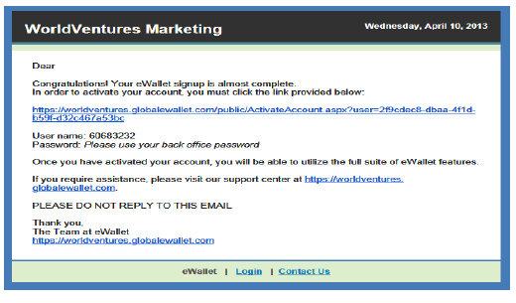
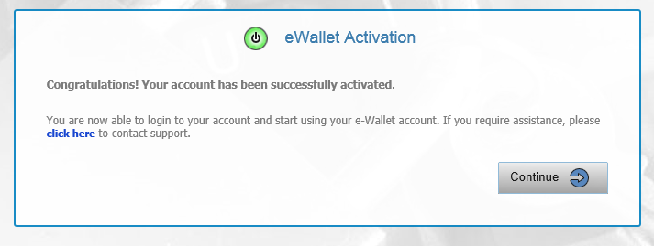
Sign in with your 8 digit member ID (e.g.60683232) and the same password as when you signed up for the World Ventures membership
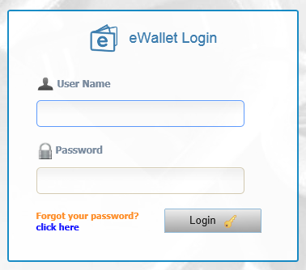

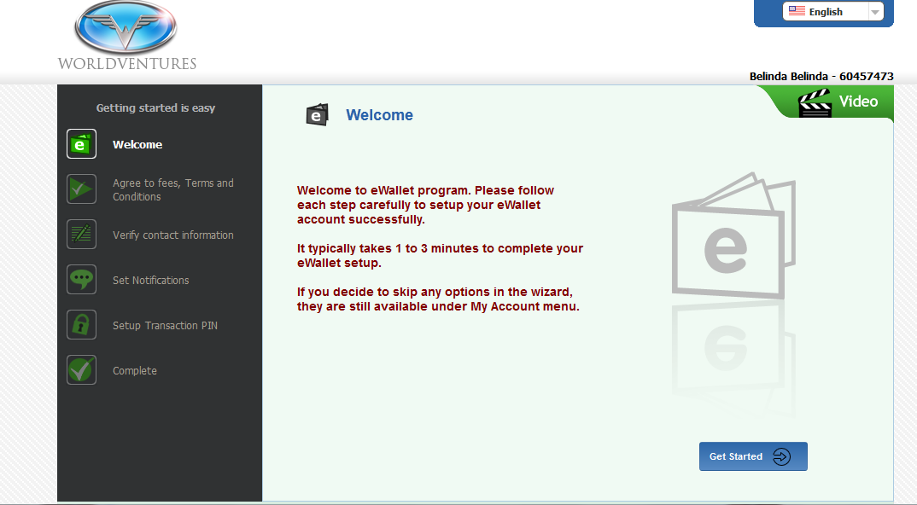
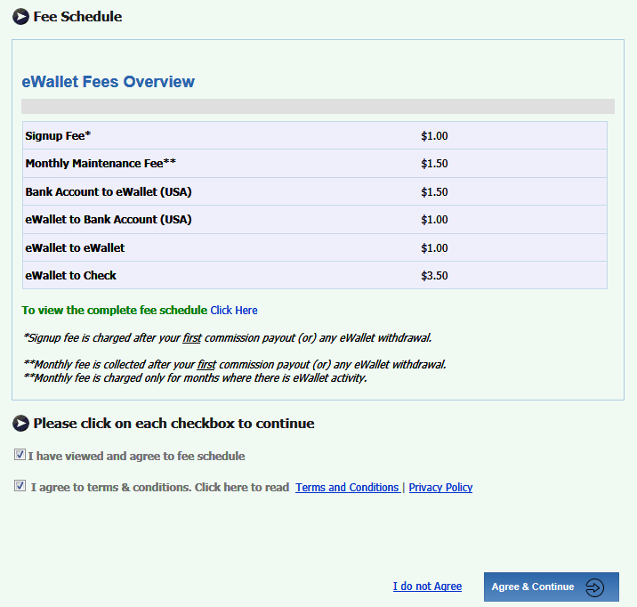
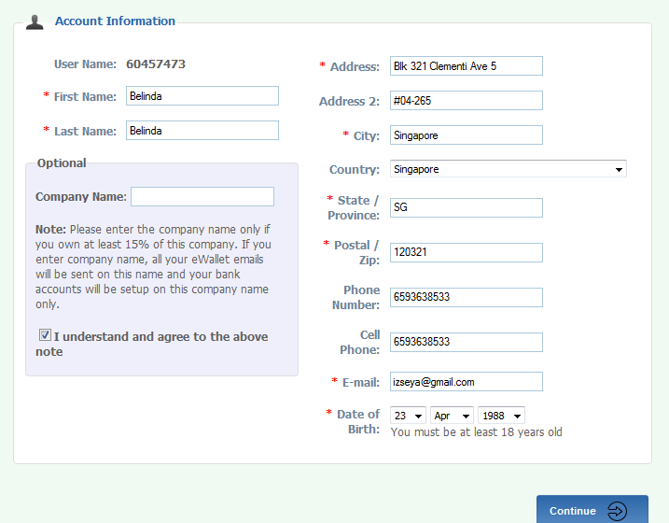

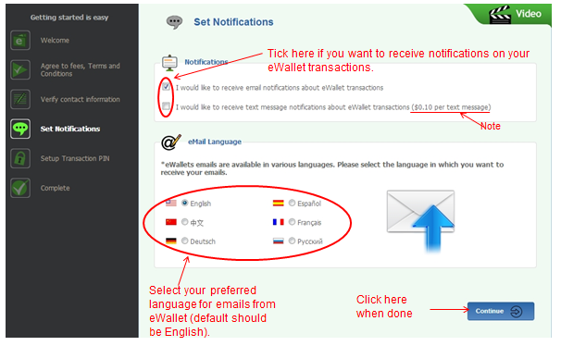

Important: Remember your transaction PIN!
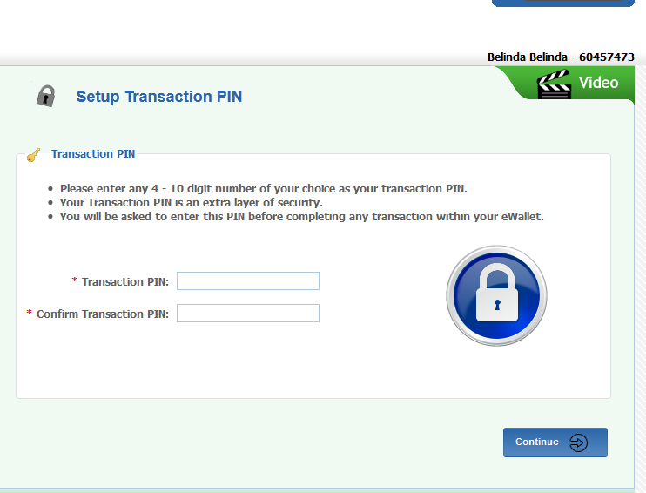
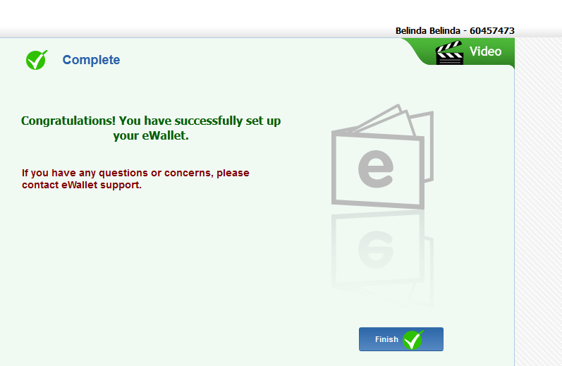

2 – eWALLET: LINK TO DEBIT CARD

Note: Complete the eWallet activation & registration for new members if you have not done so.
Login to your eWallet - https://worldventures.globaleWallet.com/MemberLogin.aspx
Username – (yr 8 digit WV membership number) & password
Select ‘My Account’ and from the dropdown list, select ‘Credit/Debit cards’.
Fill in your debit card details & enter your current residence e.g. Penang, Malaysia. Verify debit card by keying in your cvv2 code.

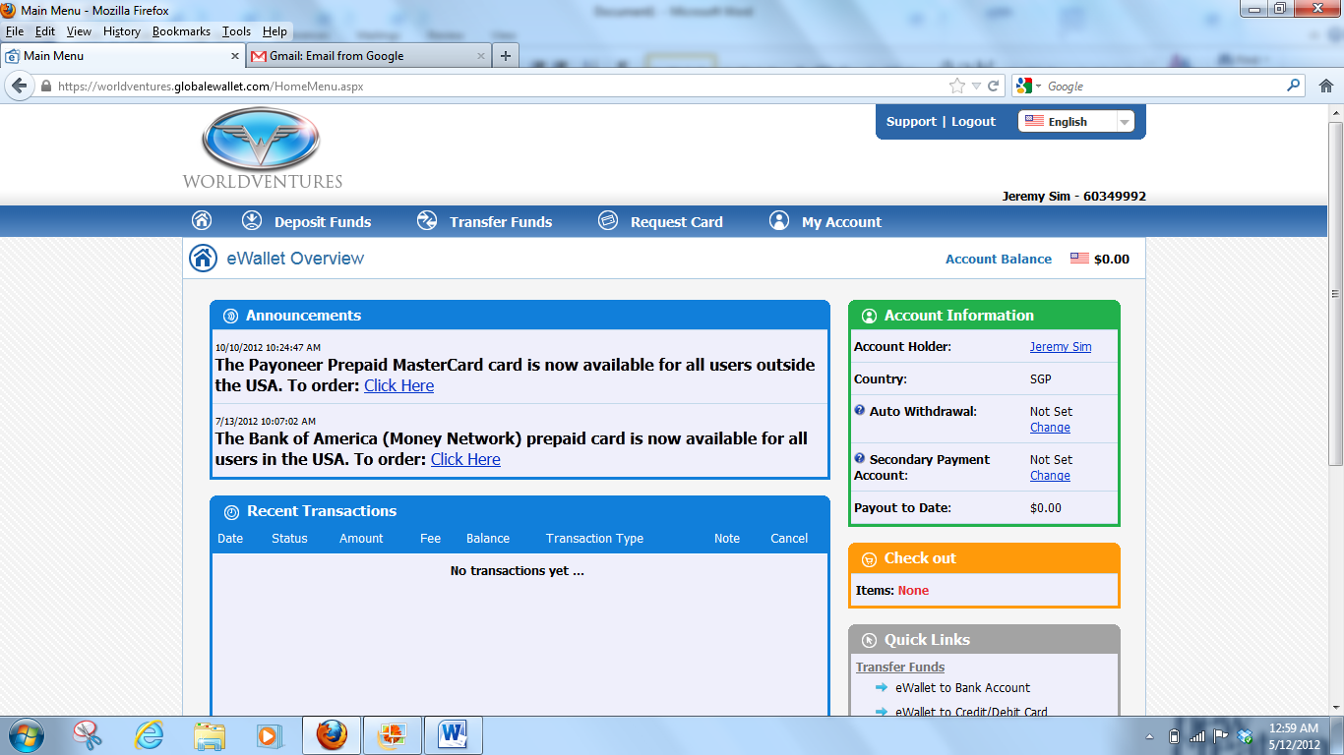
When funds are available in your eWALLET, select ‘Transfer Funds’ and from the dropdown list, select ‘eWallet to Credit/Debit card’.
INFO
- Maximum commission per transfer from eWallet to debit card is USD500 and the charge per transfer is USD6. However, for cash withdrawals the ATM, prevailing bank charges applies. Please check with your bank on the charges and withdrawal limit.
- FAQ/FEES - https://www.globaleWallet.com/Public/eWalletQuestions.aspx?s=740d7425-8304-48e3-bcf4-45d04f574d03
- Support for eWallet
- Via email: support@globaleWallet.com
- Live chat
- Call: 1-866-844-5682 ($1.00/min except login problems, forgotten passwords, and change of personal information. Available Mon-Fri 8am-6pm EST)
- eWallet guide by two WV reps http://www.youtube.com/watch?v=U5scdXFWeQU
(The video gives you an overview of eWallet. Please check with your upline or eWallet support if in doubt)
5. See page 17 for support information
3 – eWALLET: LINK TO YOUR BANK ACCOUNT

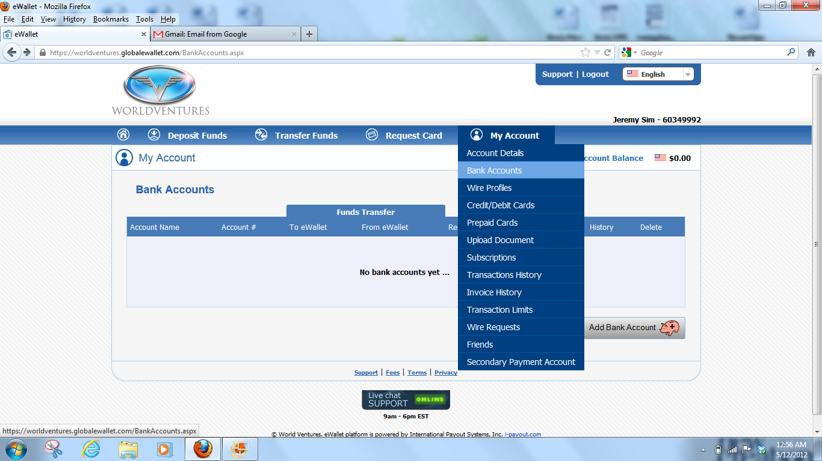

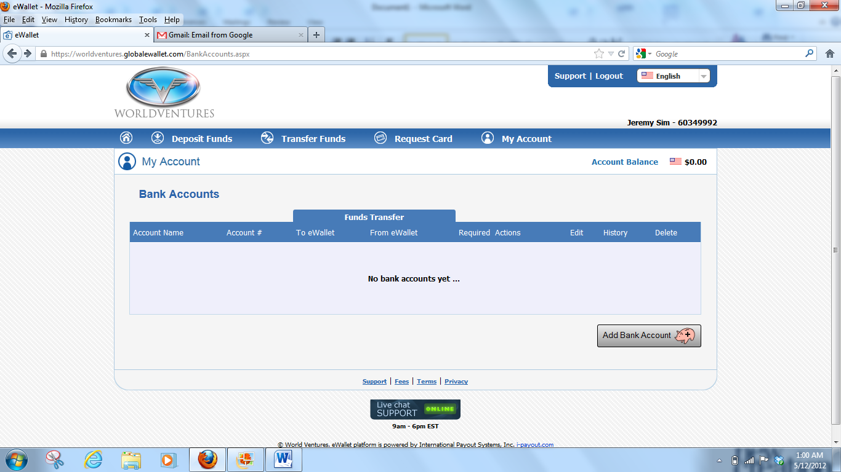
Complete the details. Please check with your bank if in doubt.
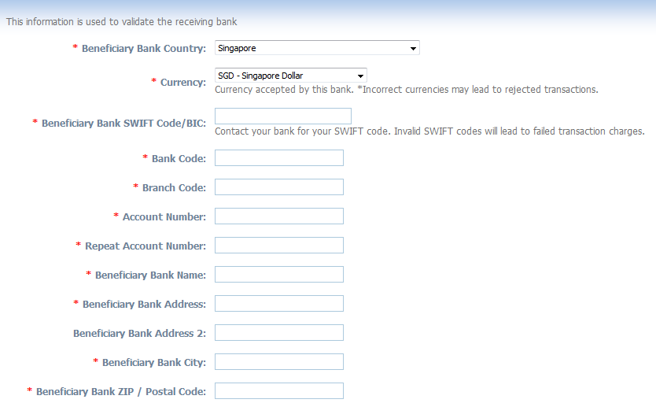

4 – eWALLET: ADD WIRE PROFILE TO TRANSFER FUNDS

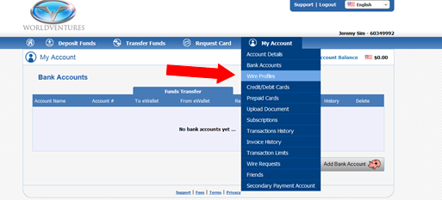
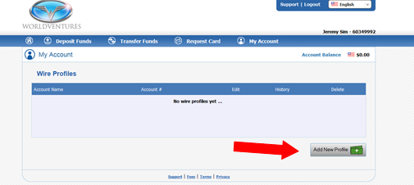
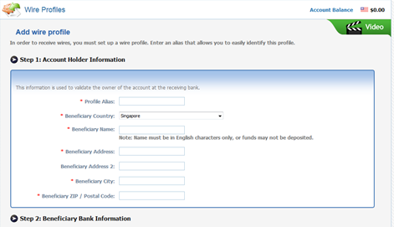

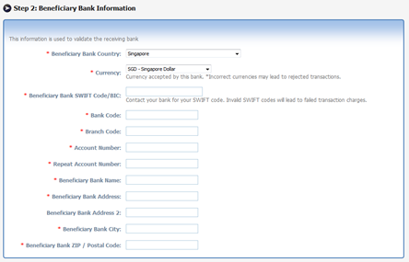

5 – APPLYING FOR WV PAYONEER DEBIT MASTERCARD

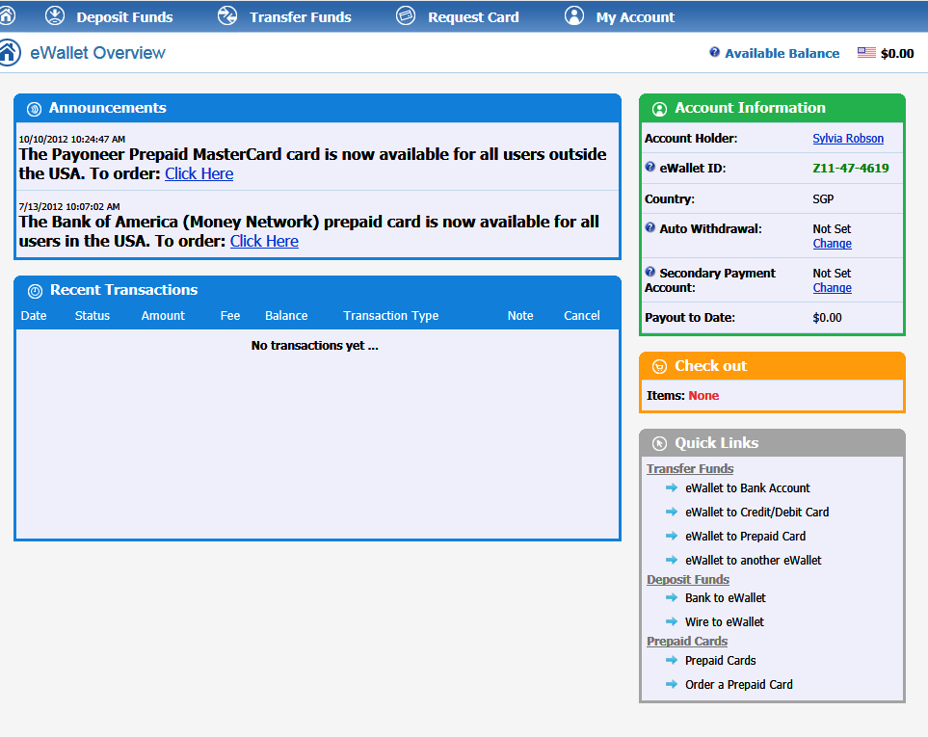

Check your particulars.
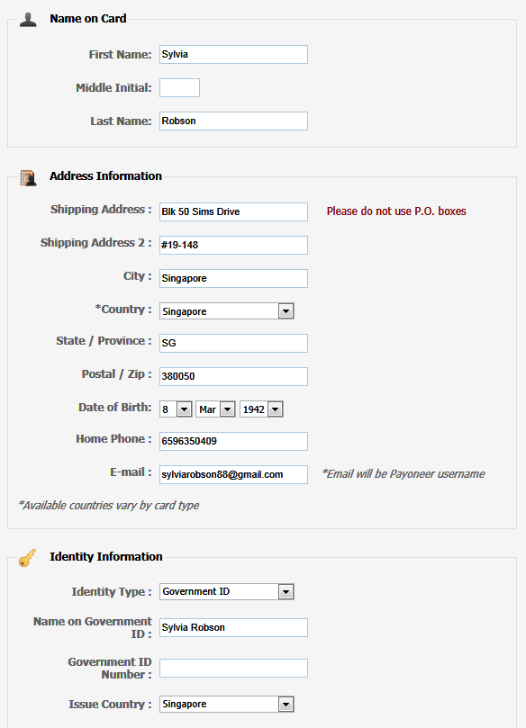
‘Identity type’ can be Govt ID (IC), Passport or Driver’s Licence. Fill in your Name & ID number
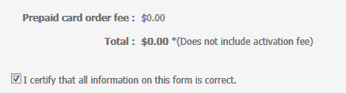
Activation fee: USD9.95
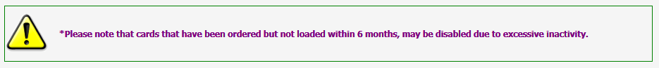
Check your particulars.
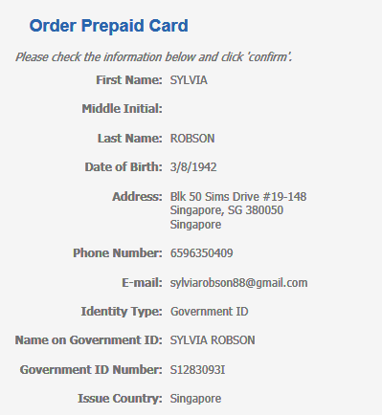
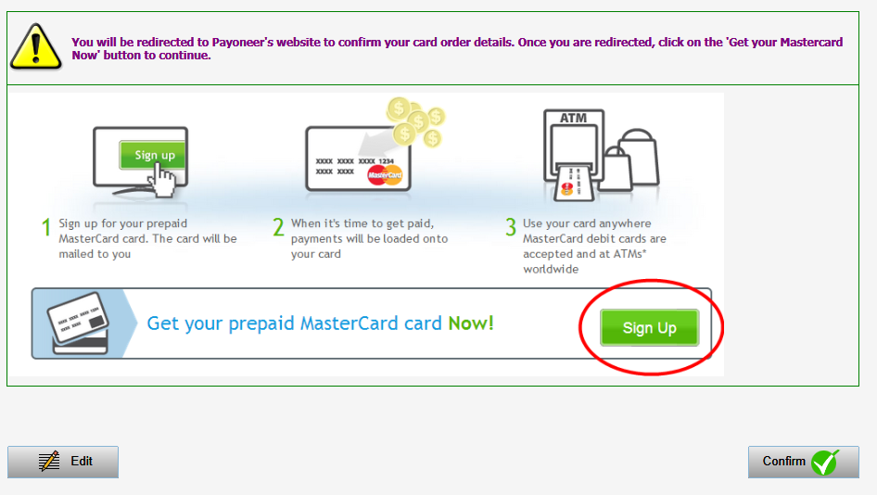

Apply for the Mastercard.
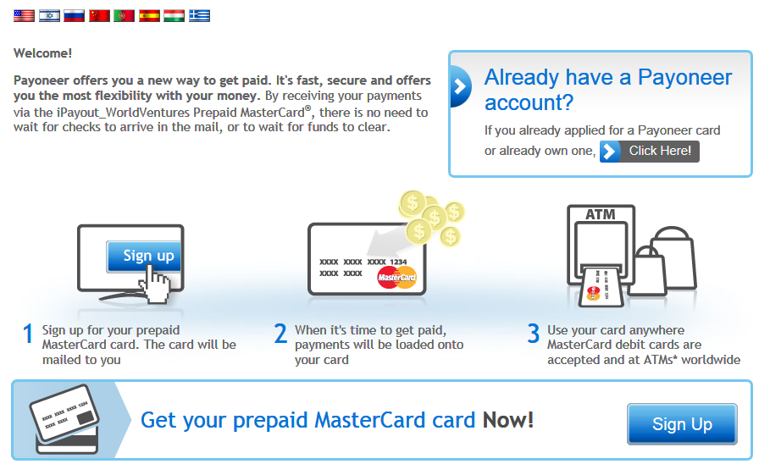
Follow the step by step instructions. First step, click on ‘Start Here’.
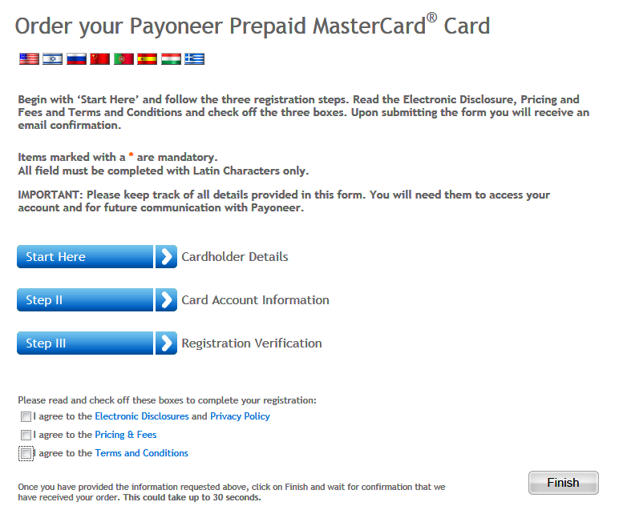
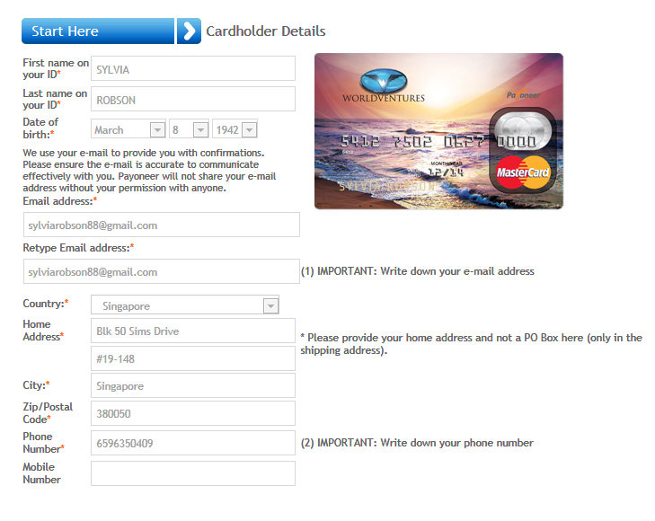

Choose your password. It must be 7 characters, alpha numeric.
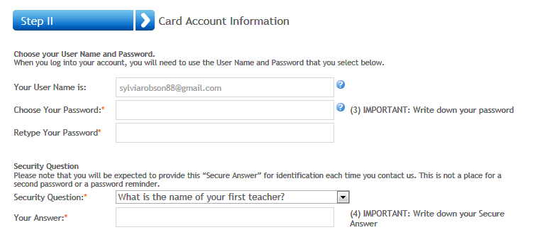

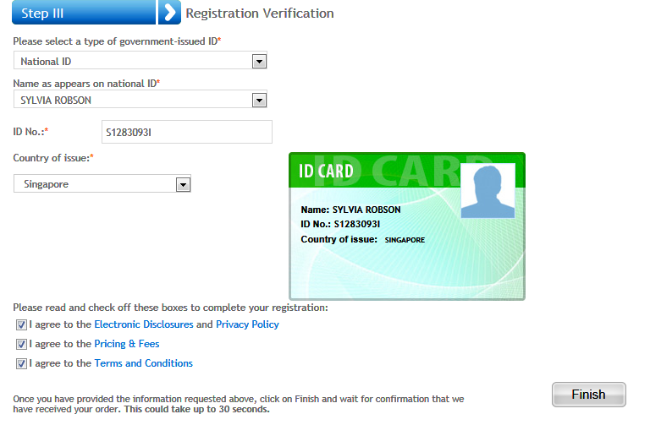
Check the details on the ID
Application for your Payoneer Debit MasterCard is done! Check your email for updates.
You will be required to activate the card when you receive it. Follow the instructions given.

6 – PRICING & FEES FOR PAYONEER DEBIT MASTERCARD

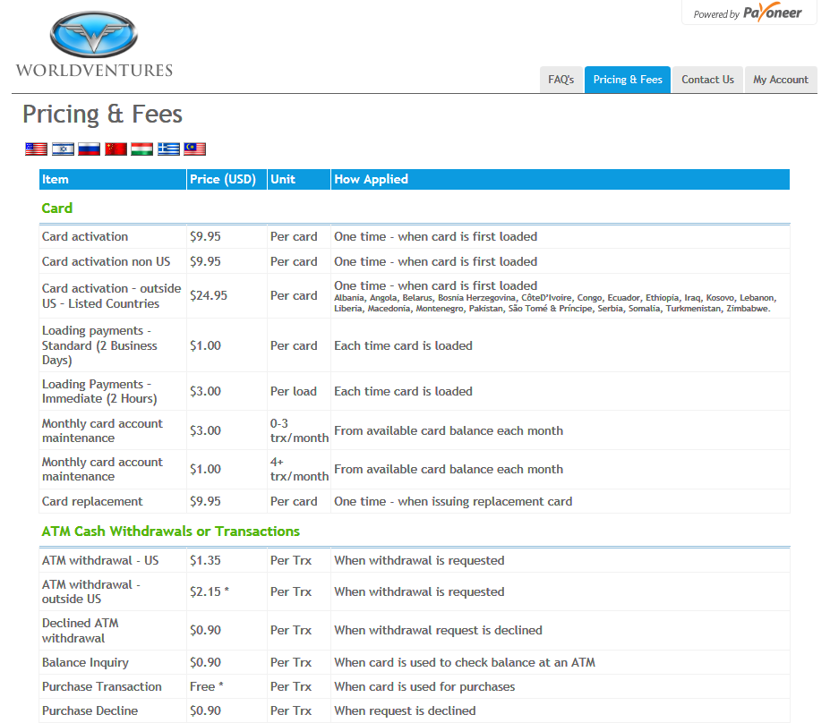

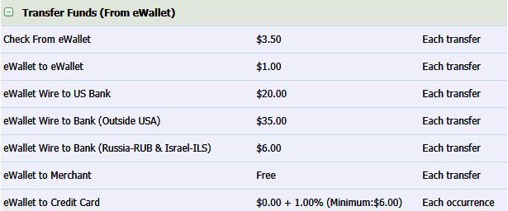
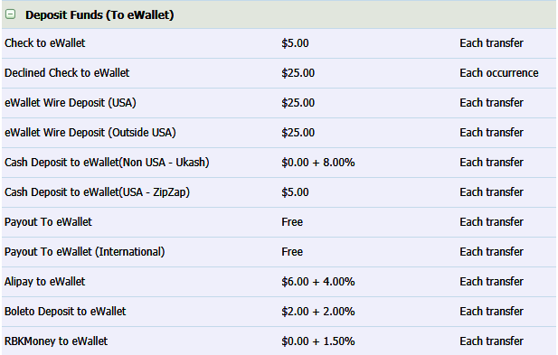
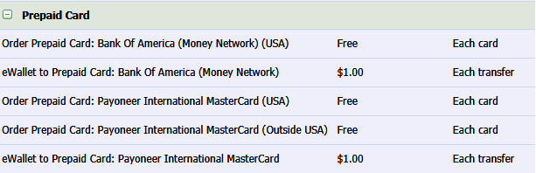
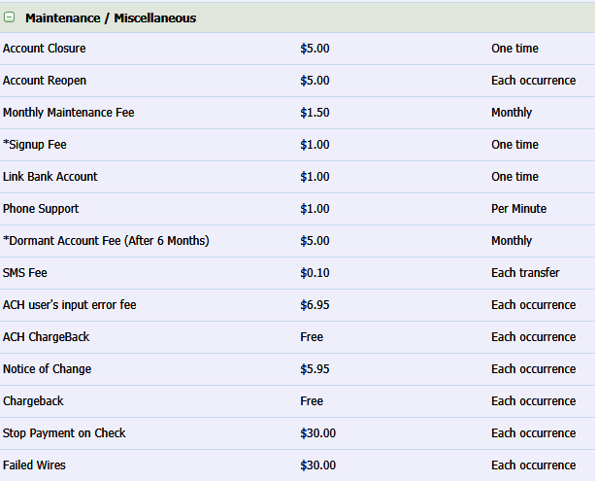

Support
Topic | Link
eWallet features | https://worldventures.globaleWallet.com/public/howitworks.aspx
eWallet - FAQ | https://worldventures.globaleWallet.com/Public/eWalletQuestions.aspx
eWallet - contacts  * eWallet related questions  (It has the current EST time) | https://worldventures.globaleWallet.com/public/ContactUs.aspx  - Call: 1-866-844-5682 ($1.00/min except login problems, forgotten passwords, and change of personal information. Please use email or live chat for other questions and inquiries)  - Available Monday to Friday between 8 AM to 6 PM EST  - Current Time is 10:57:51 PM EST  - Email: WorldVenturesMarketing@globaleWallet.com or https://worldventures.globaleWallet.com/public/eWalletSendEmail.aspx  - WV Address: 5360 Legacy Drive Bldg 1 Ste 300  Plano, Texas 75024, United States
Full eWallet account fees | https://worldventures.globaleWallet.com/Public/AccountFees.aspx
Supporting videos on YouTube on eWallet | http://www.youtube.com/watch?v=bYuYW0DH3tc
Payoneer *for WV prepaid debit card  - contact for instant answers | http://www.payoneer.com/ContactUs.aspx
Payoneer  - report lost/stolen card (available 24/7)  - Call within US  - Call outside US | 1- (646) 386 2434  1-800-251 2521 x 2 (9am – 6pm EST Mon-Fri)  1-646-658 3695 x 2 (9am – 6pm EST Mon-Fri)
Payoneer Chinese Customer Support  - email  - Hong Kong  - Shenzhen  (available 3pm – 7pm HKG time, Mon-Thurs) | Chinese.support@payoneer.com  +852-3050 8872  +86 755 862 43555
Payoneer – online email form support | http://www.payoneer.com/emailform.aspx
Payoneer - FAQ | http://www.payoneer.com/FAQ.aspx#LBT
Payoneer Address | 410 Park Avenue, 15th Floor, New York, NY 10022

Topics under eWallet Support